Project 15

Common Dialogs
When an application wishes to set a font, printer, colour or file there is a common dialog object that makes the access easier. The Common Dialog object has methods that can be used to select what information is displayed in the dialog box. These methods replace a method call action for which a value was set. The code that is below sets the Methods for Help, Font, Printer, Colour, Open and Save File. Each piece of code is behind a command Button.

Appearance
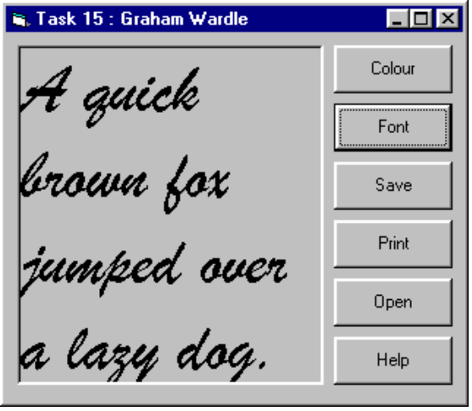

Code
Option Explicit
Private Sub CommandColour_Click()
CommonDialog1.ShowColor
Label1.BackColor = CommonDialog1.Color
End Sub
Private Sub CommandFont_Click()
' Flags property must be set
CommonDialog1.Flags = cdlCFBoth + cdlCFEffects
CommonDialog1.ShowFont
If Len(CommonDialog1.FontName) > 1 Then
Label1.FontBold = CommonDialog1.FontBold
Label1.FontItalic = CommonDialog1.FontItalic
Label1.FontStrikethru = CommonDialog1.FontStrikethru
Label1.FontUnderline = CommonDialog1.FontUnderline
Label1.FontName = CommonDialog1.FontName
Label1.FontSize = CommonDialog1.FontSize
Label1.ForeColor = CommonDialog1.Color
End If
End Sub
Private Sub Commandhelp_Click()
CommonDialog1.HelpFile = "VB5.HLP"
CommonDialog1.HelpCommand = cdlHelpContents
CommonDialog1.HelpKey = "Showhelp"
CommonDialog1.ShowHelp
End Sub
Private Sub CommandOpen_Click()
Dim filehandle As Integer
Dim temp As String
CommonDialog1.ShowOpen
filehandle = FreeFile
If CommonDialog1.filename <> "" Then
Open CommonDialog1.filename For Input As #filehandle
Input #filehandle, temp
Label1.Caption = temp
Close #filehandle
End If
End Sub
Private Sub CommandPrint_Click()
CommonDialog1.ShowPrinter
Printer.Circle (5000, 5000), 1000, RGB(0, 0, 0)
Printer.FontName = Label1.FontName
Printer.FontSize = Label1.FontSize
Printer.CurrentX = 1000
Printer.CurrentY = 1000
Printer.Print "Test Page from Task 15 Graham Wardle"
Printer.CurrentX = 0
Printer.CurrentY = 4500
Printer.Print Label1.Caption
Printer.EndDoc
End Sub
Private Sub CommandSave_Click()
Dim filehandle As Integer
CommonDialog1.ShowSave
filehandle = FreeFile
If CommonDialog1.filename <> "" Then
Open CommonDialog1.filename For Output As #filehandle
Write #filehandle, Label1.Caption
Close #filehandle
End If
End Sub

Caution
Much of the code is not fully implemented if cancel is pressed in the Printer dialog the program will still print.

Exercise
Finish off all the coding for the common dialog box so that in every case the program works every time. Some things to consider are the use of the cancel for example if the code for the printer is started it will try and print to the selected printer. This is because there is no trapping of that as an exception. If the version of Visual Basic is later than version 5 change the help file to something similar that is “VB6.hlp” rather than “VB5.hlp”.

